CO1605 Systems Analysis & Database Design
Normalization— Video Sharing Application

UNF-Unnormalized Form

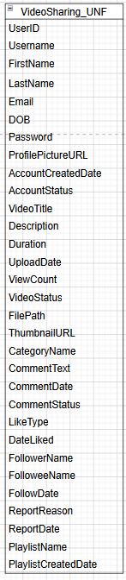
Problems:

One big flat file table with everything
- Repeating groups — one user has many videos, many comments, many likes
- Not atomic — multiple comments and likes per video in same row
- No single unique identifier for each row

1NF-First Normal Form

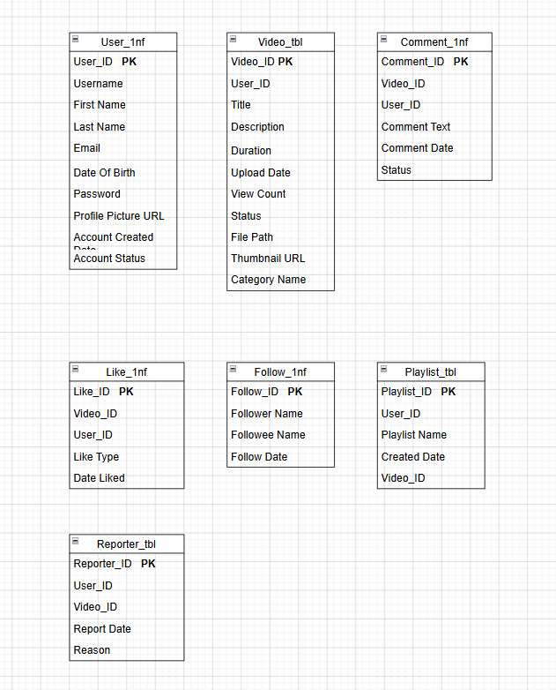
FIRST NORMAL FORM (1NF)
- Each cell contains one value only
- Each row is uniquely identifiable
- Repeating groups removed

Problems remaining:
- Partial dependencies exist — CategoryName depends only on VideoID not full key
- FollowerName/FolloweeName are not atomic identifiers — should be IDs
- PlaylistID has VideoID causing partial dependency

2NF-Second Normal Form
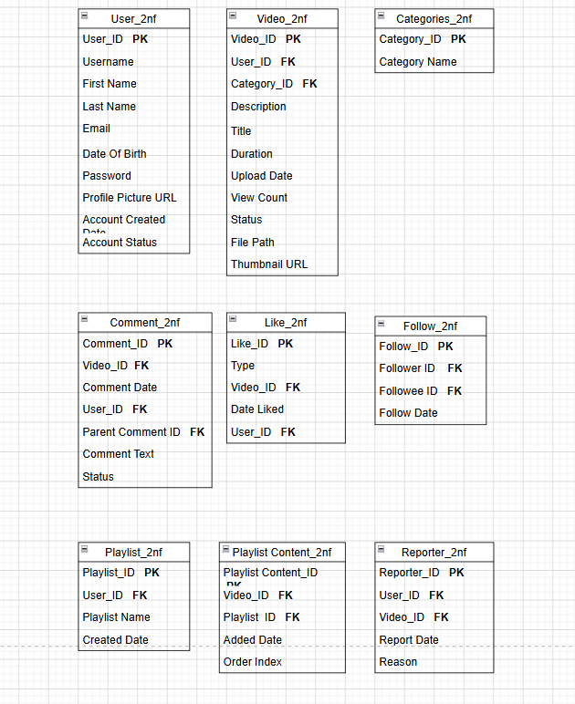

SECOND NORMAL FORM (2NF)
- Must be in 1NF
- Remove partial dependencies — every non-key attribute must depend on the whole primary key
Problems remaining:
- Transitive dependencies may still exist

3NF-Third Normal Form & ERD

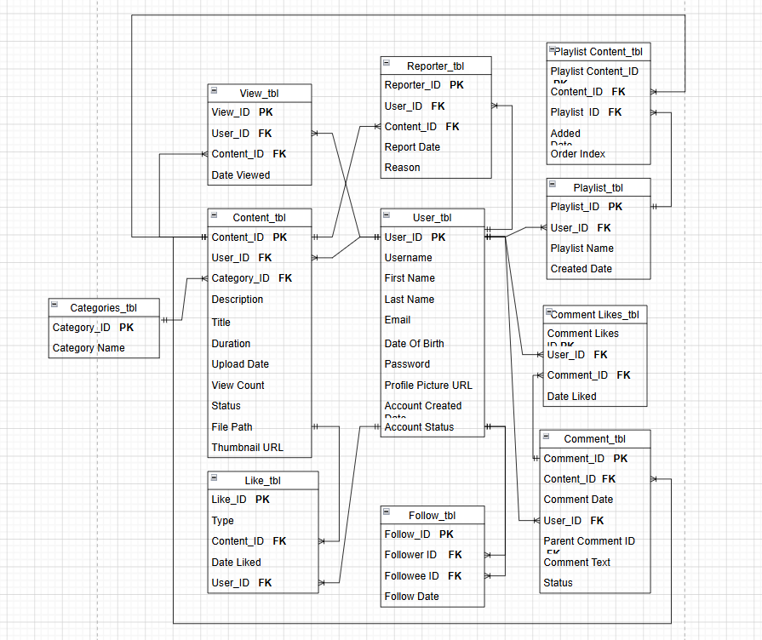

THIRD NORMAL FORM (3NF)
- Must be in 2NF
- Remove transitive dependencies — non-key attributes must depend only on the primary key, not on other non-key attributes
- Replaced “Video” with “Content”.

CO1605 Systems Analysis & Database Design
Data Dictionary — Video Sharing Application
This document defines all entities, attributes, data types, sizes, and constraints for the Video Sharing Application database. All 11 tables are designed to 3NF.
Note: ParentCommentID in Comment_tbl is NULL for top-level comments and only populated for replies.

Category_tbl — Catergory Table

Attribute | Data Type | Size | Constraint | Description
CategoryID | NUMBER | 10 | PRIMARY KEY, NOT NULL | Unique identifier for each category
CategoryName | VARCHAR2 | 100 | NOT NULL, UNIQUE | Name of the category e.g. Music, Gaming

User_tbl — User Table
Attribute | Data Type | Size | Constraint | Description
UserID | NUMBER | 10 | PRIMARY KEY, NOT NULL | Unique identifier for each user
Username | VARCHAR2 | 50 | NOT NULL, UNIQUE | Public handle/display name
FirstName | VARCHAR2 | 50 | NOT NULL | User's first name
LastName | VARCHAR2 | 50 | NOT NULL | User's last name
Email | VARCHAR2 | 100 | NOT NULL, UNIQUE | User's email address for login
DOB | DATE | - | NOT NULL, CHECK (DOB <= SYSDATE - INTERVAL '13' YEAR) | Date of birth; must be 13+
Password | VARCHAR2 | 255 | NOT NULL | Password should be encrpyted, never stored plain
ProfilePictureURL | VARCHAR2 | 500 | NULL | URL path to profile image file
AccountCreatedDate | DATE | - | NOT NULL, DEFAULT SYSDATE | Date account was created
AccountStatus | VARCHAR2 | 20 | NOT NULL, DEFAULT 'active', CHECK IN ('active','suspended','banned') | Current status of the account

Why Hashed Password?
- Anyone who gains access to the database can see every user's password directly
- If the database gets hacked, all user passwords are immediately exposed
- Users often reuse passwords across multiple sites — so one breach affects them everywhere

Content_tbl — Video/Content Table
Attribute | Data Type | Size | Constraint | Description
ContentID | NUMBER | 10 | PRIMARY KEY, NOT NULL | Unique identifier for each video
UserID | NUMBER | 10 | FOREIGN KEY → User_tbl(UserID), NOT NULL | Uploader/creator of the content
CategoryID | NUMBER | 10 | FOREIGN KEY → Categories_tbl(CategoryID), NULL | Category the video belongs to
Title | VARCHAR2 | 200 | NOT NULL | Title of the video
Description | VARCHAR2 | 2000 | NULL | Video description text
Duration | NUMBER | 6 | NOT NULL, CHECK (Duration > 0) | Duration in seconds
UploadDate | DATE | - | NOT NULL, DEFAULT SYSDATE | Date and time video was uploaded
ViewCount | NUMBER | 15 | NOT NULL, DEFAULT 0, CHECK (ViewCount >= 0) | Total number of views
Status | VARCHAR2 | 20 | NOT NULL, DEFAULT 'public', CHECK IN ('public','private','draft') | Visibility of the video
FilePath | VARCHAR2 | 500 | NOT NULL | Server path to video file
ThumbnailURL | VARCHAR2 | 500 | NULL | URL path to thumbnail image

Comment_tbl — Comment Table
Attribute | Data Type | Size | Constraint | Description
CommentID | NUMBER | 10 | PRIMARY KEY, NOT NULL | Unique identifier for each comment
ContentID | NUMBER | 10 | FOREIGN KEY → Content_tbl(ContentID), NOT NULL | Video the comment belongs to
UserID | NUMBER | 10 | FOREIGN KEY → User_tbl(UserID), NOT NULL | User who wrote the comment
ParentCommentID | NUMBER | 10 | FOREIGN KEY → Comment_tbl(CommentID), NULL | NULL for top-level comments; references parent CommentID for replies
CommentText | VARCHAR2 | 1000 | NOT NULL | Text content of the comment
CommentDate | DATE | - | NOT NULL, DEFAULT SYSDATE | Date and time comment was posted
Status | VARCHAR2 | 20 | NOT NULL, DEFAULT 'visible', CHECK IN ('visible','hidden','flagged') | Moderation status of comment

Like_tbl — Likes/Dislikes Table
Attribute | Data Type | Size | Constraint | Description
LikeID | NUMBER | 10 | PRIMARY KEY, NOT NULL | Unique identifier for each like/dislike
ContentID | NUMBER | 10 | FOREIGN KEY → Content_tbl(ContentID), NOT NULL | Video being liked or disliked
UserID | NUMBER | 10 | FOREIGN KEY → User_tbl(UserID), NOT NULL | User who liked or disliked
Type | VARCHAR2 | 10 | NOT NULL, CHECK IN ('like','dislike') | Whether action is a like or dislike
DateLiked | DATE | - | NOT NULL, DEFAULT SYSDATE | Date the like/dislike was recorded

Follow_tbl — Follow Relationship Table
Attribute | Data Type | Size | Constraint | Description
FollowID | NUMBER | 10 | PRIMARY KEY, NOT NULL | Unique identifier for each follow
FollowerID | NUMBER | 10 | FOREIGN KEY → User_tbl(UserID), NOT NULL | User who is doing the following
FolloweeID | NUMBER | 10 | FOREIGN KEY → User_tbl(UserID), NOT NULL | User who is being followed
FollowDate | DATE | - | NOT NULL, DEFAULT SYSDATE | Date the follow occurred

Reporter_tbl — Content Report Table
Attribute | Data Type | Size | Constraint | Description
ReporterID | NUMBER | 10 | PRIMARY KEY, NOT NULL | Unique identifier for each report
UserID | NUMBER | 10 | FOREIGN KEY → User_tbl(UserID), NOT NULL | User who submitted the report
ContentID | NUMBER | 10 | FOREIGN KEY → Content_tbl(ContentID), NOT NULL | Content being reported
Reason | VARCHAR2 | 500 | NOT NULL | Reason given for the report
ReportDate | DATE | - | NOT NULL, DEFAULT SYSDATE | Date report was submitted

View_tbl — Video View Tracking Table
Attribute | Data Type | Size | Constraint | Description
ViewID | NUMBER | 10 | PRIMARY KEY, NOT NULL | Unique identifier for each view event
UserID | NUMBER | 10 | FOREIGN KEY → User_tbl(UserID), NOT NULL | User who watched the video
ContentID | NUMBER | 10 | FOREIGN KEY → Content_tbl(ContentID), NOT NULL | Video that was watched
DateViewed | DATE | - | NOT NULL, DEFAULT SYSDATE | Date and time the video was viewed

Playlists_tbl — Playlist Table
Attribute | Data Type | Size | Constraint | Description
PlaylistID | NUMBER | 10 | PRIMARY KEY, NOT NULL | Unique identifier for each playlist
UserID | NUMBER | 10 | FOREIGN KEY → User_tbl(UserID), NOT NULL | User who created the playlist
PlaylistName | VARCHAR2 | 200 | NOT NULL | Name of the playlist
CreatedDate | DATE | - | NOT NULL, DEFAULT SYSDATE | Date the playlist was created

PlaylistContent_tbl — Playlist-Video Junction Table
Attribute | Data Type | Size | Constraint | Description
PlaylistContentID | NUMBER | 10 | PRIMARY KEY, NOT NULL | Unique identifier for each entry
PlaylistID | NUMBER | 10 | FOREIGN KEY → Playlists_tbl(PlaylistID), NOT NULL | The playlist this entry belongs to
ContentID | NUMBER | 10 | FOREIGN KEY → Content_tbl(ContentID), NOT NULL | The video in this playlist
AddedDate | DATE | - | NOT NULL, DEFAULT SYSDATE | Date video was added to playlist
OrderIndex | NUMBER | 5 | NOT NULL, CHECK (OrderIndex >= 1) | Position of video in the playlist

CommentLikes_tbl — Comment Likes Table
Attribute | Data Type | Size | Constraint | Description
CommentLikeID | NUMBER | 10 | PRIMARY KEY, NOT NULL | Unique identifier for each comment like
CommentID | NUMBER | 10 | FOREIGN KEY → Comment_tbl(CommentID), NOT NULL | Comment being liked
UserID | NUMBER | 10 | FOREIGN KEY → User_tbl(UserID), NOT NULL | User who liked the comment
DateLiked | DATE | - | NOT NULL, DEFAULT SYSDATE | Date the like was recorded

Create Table Scripts & Constraints:
-- 1. CATEGORIES_TBL
CREATE TABLE CATEGORIES_TBL (
CategoryID NUMBER(10) NOT NULL,
CategoryName VARCHAR2(100) NOT NULL,
CONSTRAINT pk_category PRIMARY KEY (CategoryID),
CONSTRAINT uq_category_name UNIQUE (CategoryName)
);

-- 2. USER_TBL
CREATE TABLE USER_TBL (
UserID NUMBER(10) NOT NULL,
Username VARCHAR2(50) NOT NULL,
FirstName VARCHAR2(50) NOT NULL,
LastName VARCHAR2(50) NOT NULL,
Email VARCHAR2(100) NOT NULL,
DOB DATE NOT NULL,
PasswordHash VARCHAR2(255) NOT NULL,
ProfilePictureURL VARCHAR2(500),
AccountCreatedDate DATE DEFAULT SYSDATE NOT NULL,
AccountStatus VARCHAR2(20) DEFAULT 'active' NOT NULL,
CONSTRAINT pk_user PRIMARY KEY (UserID),
CONSTRAINT uq_username UNIQUE (Username),
CONSTRAINT uq_email UNIQUE (Email),
CONSTRAINT chk_dob CHECK (DOB <= SYSDATE - INTERVAL '13' YEAR),
CONSTRAINT chk_user_status CHECK (AccountStatus IN ('active','suspended','banned'))
);

-- 3. CONTENT_TBL
CREATE TABLE CONTENT_TBL (
ContentID NUMBER(10) NOT NULL,
UserID NUMBER(10) NOT NULL,
CategoryID NUMBER(10),
Title VARCHAR2(200) NOT NULL,
Description VARCHAR2(2000),
Duration NUMBER(6) NOT NULL,
UploadDate DATE DEFAULT SYSDATE NOT NULL,
ViewCount NUMBER(15) DEFAULT 0 NOT NULL,
Status VARCHAR2(20) DEFAULT 'public' NOT NULL,
FilePath VARCHAR2(500) NOT NULL,
ThumbnailURL VARCHAR2(500),
CONSTRAINT pk_content PRIMARY KEY (ContentID),
CONSTRAINT fk_content_user FOREIGN KEY (UserID) REFERENCES USER_TBL(UserID),
CONSTRAINT fk_content_category FOREIGN KEY (CategoryID) REFERENCES CATEGORIES_TBL(CategoryID),
CONSTRAINT chk_duration CHECK (Duration > 0),
CONSTRAINT chk_viewcount CHECK (ViewCount >= 0),
CONSTRAINT chk_content_status CHECK (Status IN ('public','private','draft'))
);

-- 4. COMMENT_TBL
CREATE TABLE COMMENT_TBL (
CommentID NUMBER(10) NOT NULL,
ContentID NUMBER(10) NOT NULL,
UserID NUMBER(10) NOT NULL,
ParentCommentID NUMBER(10),
CommentText VARCHAR2(1000) NOT NULL,
CommentDate DATE DEFAULT SYSDATE NOT NULL,
Status VARCHAR2(20) DEFAULT 'visible' NOT NULL,
CONSTRAINT pk_comment PRIMARY KEY (CommentID),
CONSTRAINT fk_comment_content FOREIGN KEY (ContentID) REFERENCES CONTENT_TBL(ContentID),
CONSTRAINT fk_comment_user FOREIGN KEY (UserID) REFERENCES USER_TBL(UserID),
CONSTRAINT fk_comment_parent FOREIGN KEY (ParentCommentID) REFERENCES COMMENT_TBL(CommentID),
CONSTRAINT chk_comment_status CHECK (Status IN ('visible','hidden','flagged'))
);

-- 5. LIKE_TBL
CREATE TABLE LIKE_TBL (
LikeID NUMBER(10) NOT NULL,
ContentID NUMBER(10) NOT NULL,
UserID NUMBER(10) NOT NULL,
Type VARCHAR2(10) NOT NULL,
DateLiked DATE DEFAULT SYSDATE NOT NULL,
CONSTRAINT pk_like PRIMARY KEY (LikeID),
CONSTRAINT fk_like_content FOREIGN KEY (ContentID) REFERENCES CONTENT_TBL(ContentID),
CONSTRAINT fk_like_user FOREIGN KEY (UserID) REFERENCES USER_TBL(UserID),
CONSTRAINT chk_like_type CHECK (Type IN ('like','dislike'))
);

-- 6. FOLLOW_TBL
CREATE TABLE FOLLOW_TBL (
FollowID NUMBER(10) NOT NULL,
FollowerID NUMBER(10) NOT NULL,
FolloweeID NUMBER(10) NOT NULL,
FollowDate DATE DEFAULT SYSDATE NOT NULL,
CONSTRAINT pk_follow PRIMARY KEY (FollowID),
CONSTRAINT fk_follower FOREIGN KEY (FollowerID) REFERENCES USER_TBL(UserID),
CONSTRAINT fk_followee FOREIGN KEY (FolloweeID) REFERENCES USER_TBL(UserID),
CONSTRAINT chk_no_self_follow CHECK (FollowerID != FolloweeID)
);

-- 7. REPORTER_TBL
CREATE TABLE REPORTER_TBL (
ReporterID NUMBER(10) NOT NULL,
UserID NUMBER(10) NOT NULL,
ContentID NUMBER(10) NOT NULL,
Reason VARCHAR2(500) NOT NULL,
ReportDate DATE DEFAULT SYSDATE NOT NULL,
CONSTRAINT pk_reporter PRIMARY KEY (ReporterID),
CONSTRAINT fk_reporter_user FOREIGN KEY (UserID) REFERENCES USER_TBL(UserID),
CONSTRAINT fk_reporter_content FOREIGN KEY (ContentID) REFERENCES CONTENT_TBL(ContentID)
);

-- 8. VIEW_TBL
CREATE TABLE VIEW_TBL (
ViewID NUMBER(10) NOT NULL,
UserID NUMBER(10) NOT NULL,
ContentID NUMBER(10) NOT NULL,
DateViewed DATE DEFAULT SYSDATE NOT NULL,
CONSTRAINT pk_view PRIMARY KEY (ViewID),
CONSTRAINT fk_view_user FOREIGN KEY (UserID) REFERENCES USER_TBL(UserID),
CONSTRAINT fk_view_content FOREIGN KEY (ContentID) REFERENCES CONTENT_TBL(ContentID)
);

-- 9. PLAYLISTS_TBL
CREATE TABLE PLAYLISTS_TBL (
PlaylistID NUMBER(10) NOT NULL,
UserID NUMBER(10) NOT NULL,
PlaylistName VARCHAR2(200) NOT NULL,
CreatedDate DATE DEFAULT SYSDATE NOT NULL,
CONSTRAINT pk_playlist PRIMARY KEY (PlaylistID),
CONSTRAINT fk_playlist_user FOREIGN KEY (UserID) REFERENCES USER_TBL(UserID)
);

-- 10. PLAYLISTCONTENT_TBL
CREATE TABLE PLAYLISTCONTENT_TBL (
PlaylistContentID NUMBER(10) NOT NULL,
PlaylistID NUMBER(10) NOT NULL,
ContentID NUMBER(10) NOT NULL,
AddedDate DATE DEFAULT SYSDATE NOT NULL,
OrderIndex NUMBER(5) NOT NULL,
CONSTRAINT pk_playlistcontent PRIMARY KEY (PlaylistContentID),
CONSTRAINT fk_pc_playlist FOREIGN KEY (PlaylistID) REFERENCES PLAYLISTS_TBL(PlaylistID),
CONSTRAINT fk_pc_content FOREIGN KEY (ContentID) REFERENCES CONTENT_TBL(ContentID),
CONSTRAINT chk_order_index CHECK (OrderIndex >= 1)
);

-- 11. COMMENTLIKES_TBL
CREATE TABLE COMMENTLIKES_TBL (
CommentLikeID NUMBER(10) NOT NULL,
CommentID NUMBER(10) NOT NULL,
UserID NUMBER(10) NOT NULL,
DateLiked DATE DEFAULT SYSDATE NOT NULL,
CONSTRAINT pk_commentlike PRIMARY KEY (CommentLikeID),
CONSTRAINT fk_cl_comment FOREIGN KEY (CommentID) REFERENCES COMMENT_TBL(CommentID),
CONSTRAINT fk_cl_user FOREIGN KEY (UserID) REFERENCES USER_TBL(UserID)
);

Demonstrations:
1. Show all videos with their creator and category
SELECT c.Title, u.Username, cat.CategoryName, c.ViewCount, c.Status
FROM CONTENT_TBL c
JOIN USER_TBL u ON c.UserID = u.UserID
JOIN CATEGORIES_TBL cat ON c.CategoryID = cat.CategoryID
ORDER BY c.ViewCount DESC;
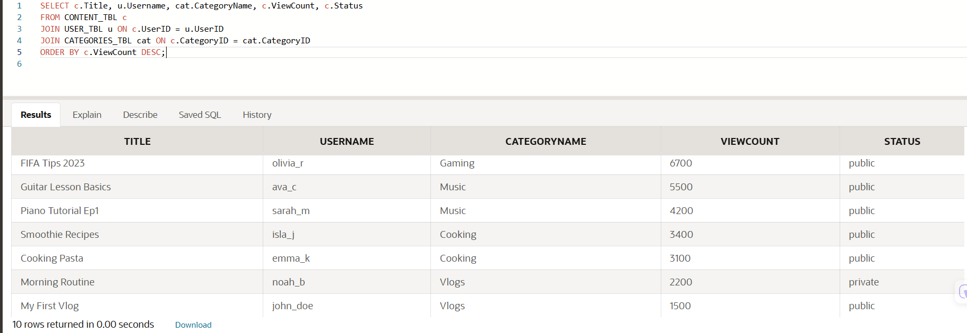

2. Show all comments on a specific video including replies
SELECT c.CommentID, u.Username, c.CommentText, c.ParentCommentID, c.CommentDate
FROM COMMENT_TBL c
JOIN USER_TBL u ON c.UserID = u.UserID
WHERE c.ContentID = 1
ORDER BY c.CommentDate;
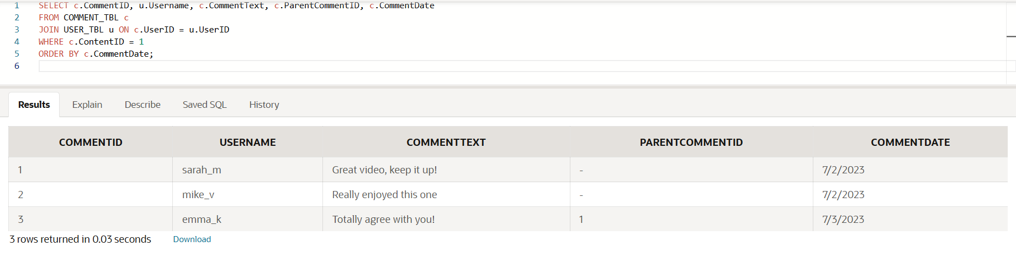

3. Show total likes and dislikes per video
SELECT c.Title,
SUM(CASE WHEN l.Type = 'like' THEN 1 ELSE 0 END) AS TotalLikes,
SUM(CASE WHEN l.Type = 'dislike' THEN 1 ELSE 0 END) AS TotalDislikes
FROM CONTENT_TBL c
JOIN LIKE_TBL l ON c.ContentID = l.ContentID
GROUP BY c.Title
ORDER BY TotalLikes DESC;
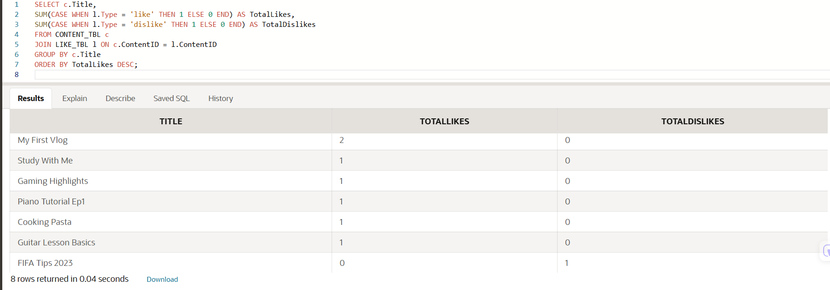

4. Show all followers of a specific user
SELECT u.Username AS Follower, u2.Username AS Following
FROM FOLLOW_TBL f
JOIN USER_TBL u ON f.FollowerID = u.UserID
JOIN USER_TBL u2 ON f.FolloweeID = u2.UserID
WHERE f.FolloweeID = 1;
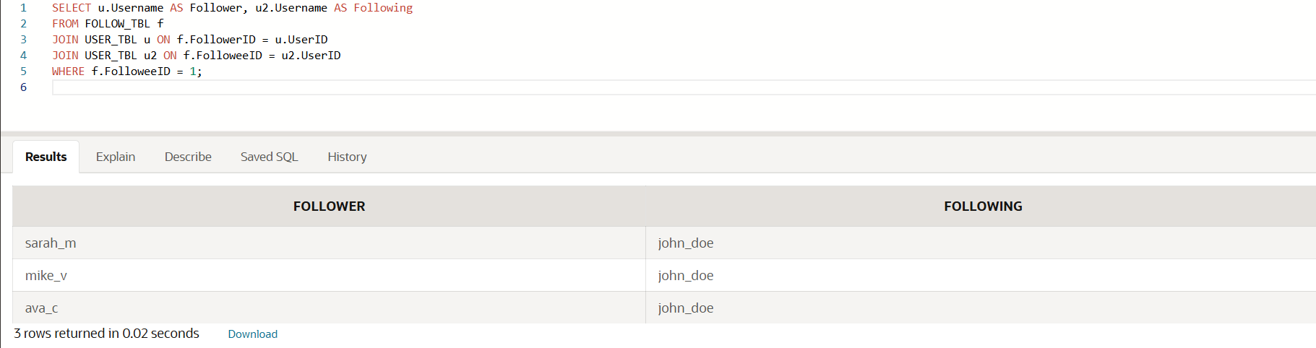

5. Show most viewed videos
SELECT c.Title, u.Username, c.ViewCount
FROM CONTENT_TBL c
JOIN USER_TBL u ON c.UserID = u.UserID
ORDER BY c.ViewCount DESC;
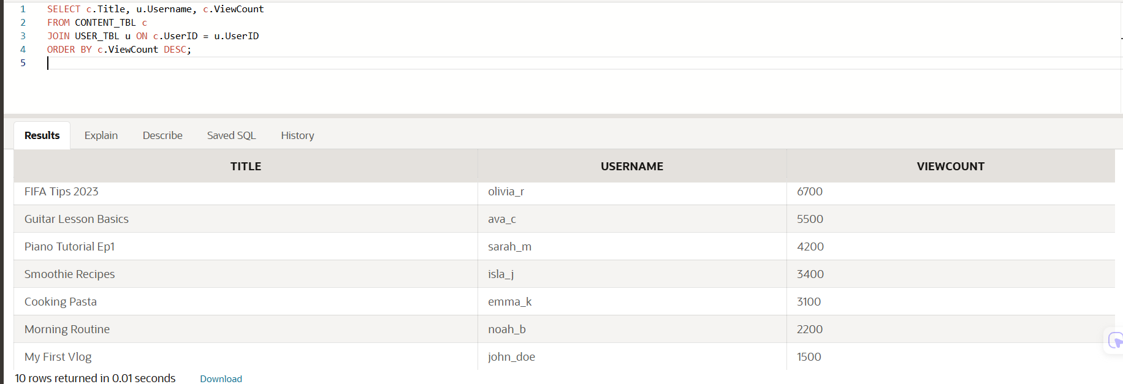

6. Show all reported content with reason
SELECT u.Username AS ReportedBy, c.Title AS VideoReported, r.Reason, r.ReportDate
FROM REPORTER_TBL r
JOIN USER_TBL u ON r.UserID = u.UserID
JOIN CONTENT_TBL c ON r.ContentID = c.ContentID
ORDER BY r.ReportDate;
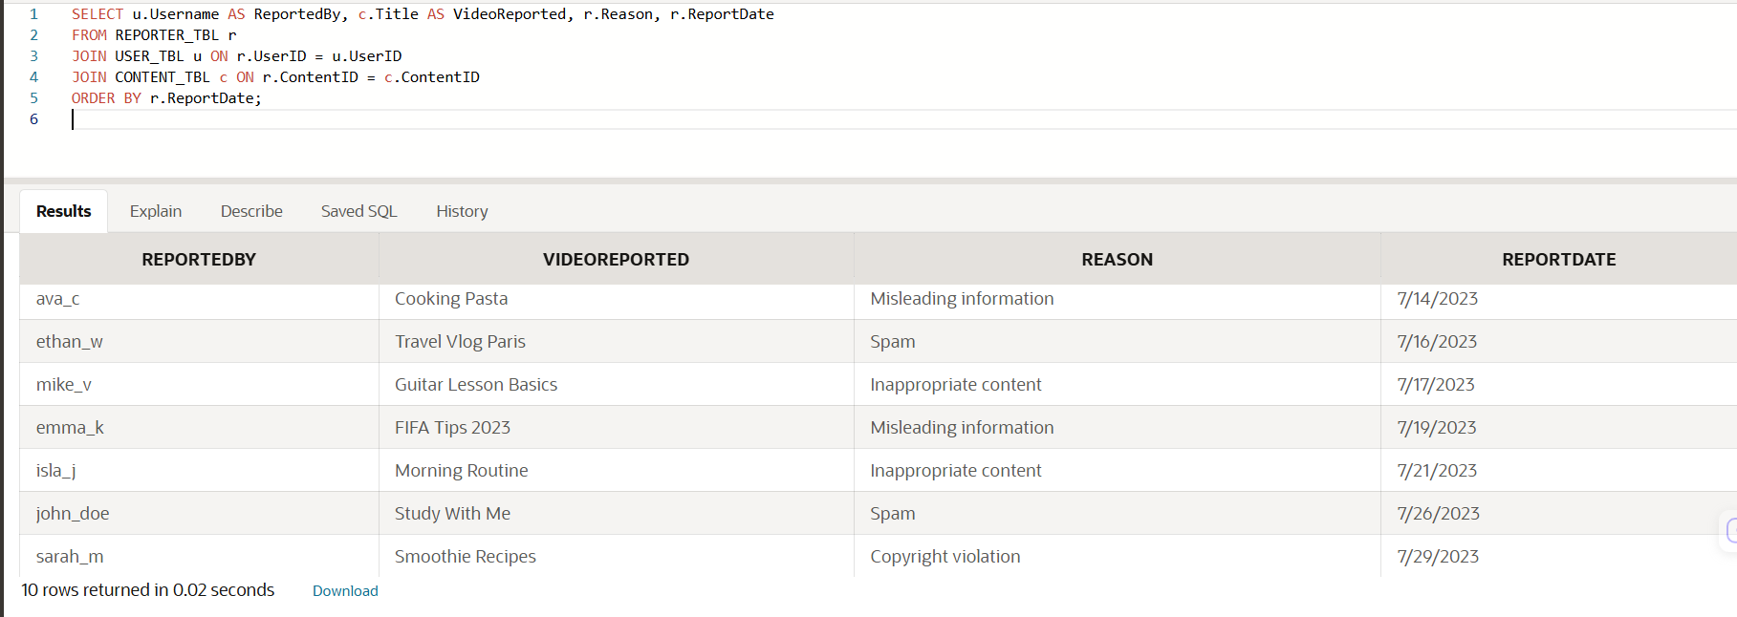

7. Show all videos in a specific playlist
SELECT p.PlaylistName, c.Title, pc.OrderIndex, pc.AddedDate
FROM PLAYLISTCONTENT_TBL pc
JOIN PLAYLISTS_TBL p ON pc.PlaylistID = p.PlaylistID
JOIN CONTENT_TBL c ON pc.ContentID = c.ContentID
WHERE pc.PlaylistID = 1
ORDER BY pc.OrderIndex;
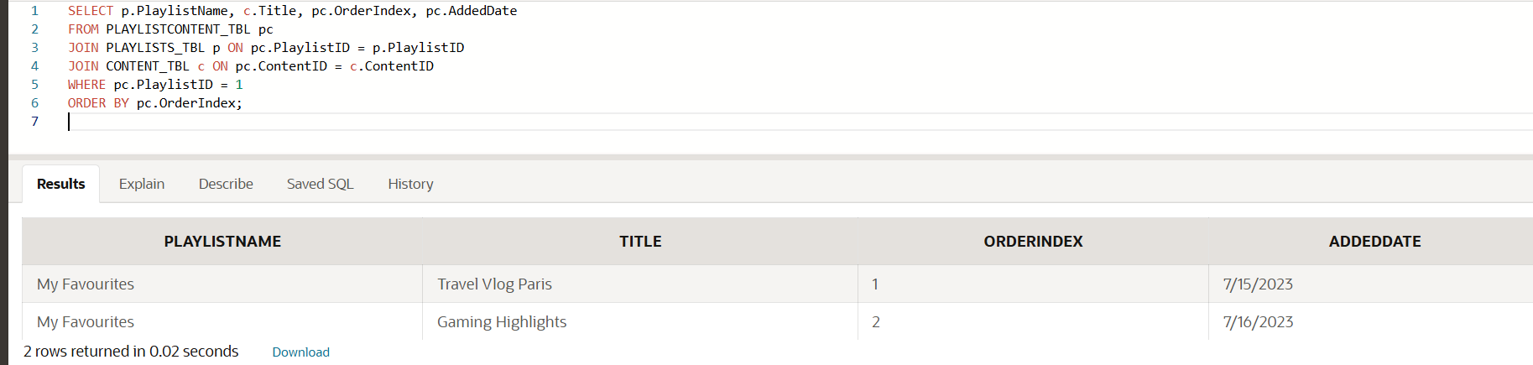

8. Show users who liked a comment and which comment
SELECT u.Username, co.CommentText, cl.DateLiked
FROM COMMENTLIKES_TBL cl
JOIN USER_TBL u ON cl.UserID = u.UserID
JOIN COMMENT_TBL co ON cl.CommentID = co.CommentID
ORDER BY cl.DateLiked;
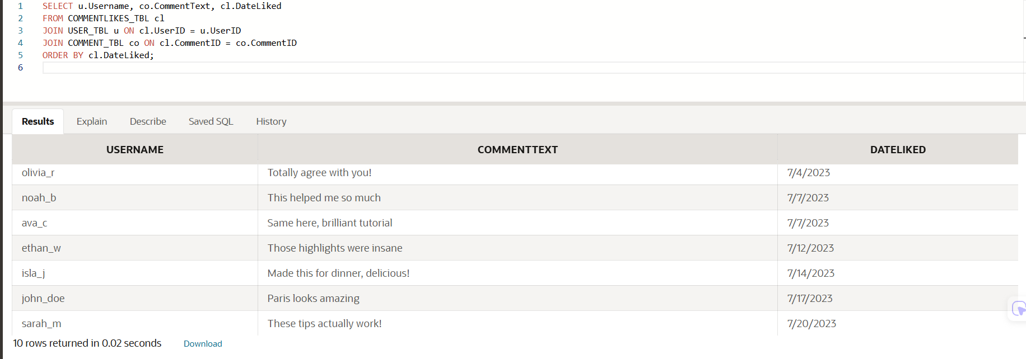

9. Show active users who have uploaded videos
SELECT DISTINCT u.Username, u.AccountStatus, COUNT(c.ContentID) AS TotalVideos
FROM USER_TBL u
JOIN CONTENT_TBL c ON u.UserID = c.UserID
WHERE u.AccountStatus = 'active'
GROUP BY u.Username, u.AccountStatus
ORDER BY TotalVideos DESC;
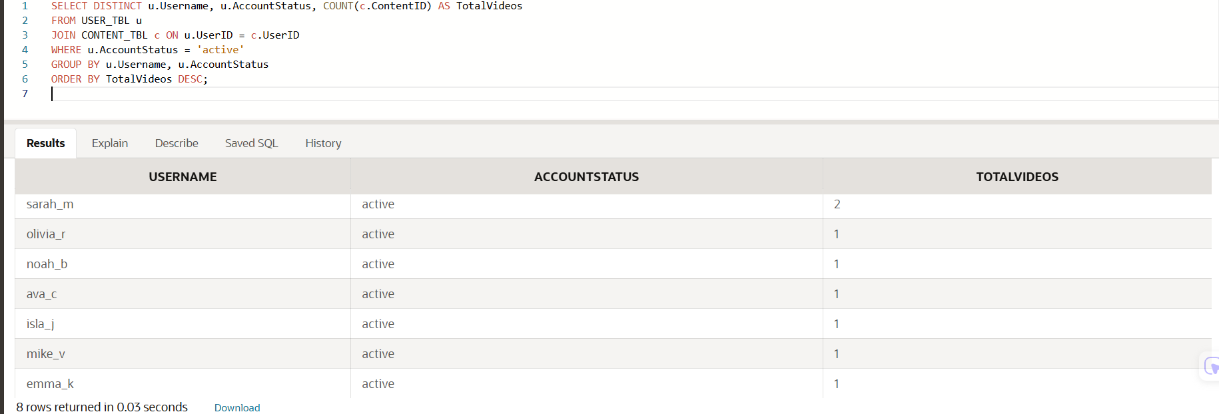

10. Show all videos watched by a specific user
SELECT u.Username, c.Title, v.DateViewed
FROM VIEW_TBL v
JOIN USER_TBL u ON v.UserID = u.UserID
JOIN CONTENT_TBL c ON v.ContentID = c.ContentID
WHERE v.UserID = 1
ORDER BY v.DateViewed;
